Important Links

* [Ads Annotation Components](https://docs.google.com/spreadsheets/d/19zqsQFof-eNFHIcNJwl6Pf7NXAziChSLUuWt-90YSaE/edit#gid=885707007)
* [Ads Infra “Change Info” API Design](https://docs.google.com/document/d/1LPjA6CZWPbEwwsDGW9Ewt0nft7H0YTr_OG5eSSmOUUk/edit#heading=h.muhiym3rtje4)
* [Ads Infra “Experiment Info” API Design](https://docs.google.com/document/d/1S_RDtpgC71RgkT2CBKXxNHUYTzBnJv3VPMLxYWXvzvA/edit#heading=h.muhiym3rtje4)
* [2022 CPC Test & Product Launches](https://docs.google.com/spreadsheets/d/1t2rLsjeBsqD_5ELYj5nD07RktySlHLXsxu_5MKzADAk/edit?pli=1#gid=2)
* [JIRA Board - Ads Metadata and Changes](https://jirap.corp.ebay.com/secure/RapidBoard.jspa?rapidView=23675&selectedIssue=SHEPHERD-1468&quickFilter=66719)

# Oct 20, 2022 DSS meeting

DSS important tables

Sales table

Impression is outside of scope of Dwrm service management

Can work with DSS table and tags

There’s a batch job that doesn’t use Dwrm

More and more automation is being done as well

DSS follows

DSS standard and Ads specific

DSS not doing real-time data set

Use production roll out date

# Oct 19, 2022

ES index name index metrics:

[https://esadsquality-kibanaslc.vip.ebay.com/app/monitoring#/elasticsearch/indices/change_info_metadata[…]:!f,value:10000),time:(from:now-1h,to:now))](https://esadsquality-kibanaslc.vip.ebay.com/app/monitoring#/elasticsearch/indices/change_info_metadata_2021?_g=(cluster_uuid:bXiRekCuQD6BPbObq9ssYw,refreshInterval:(pause:!f,value:10000),time:(from:now-1h,to:now)))

Expired category API

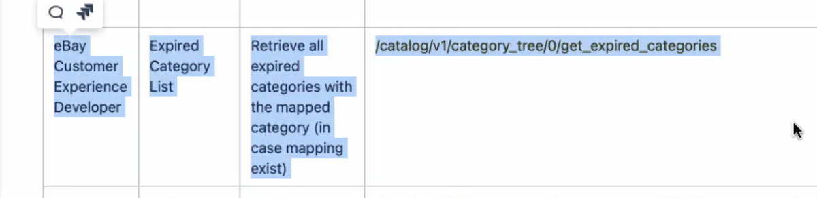

Missing daily digest reports on PLA for Tim.

Rheos Change metadata in QA

<https://estess762test-kibanaslc.stratus.qa.ebay.com/app/discover#/?_g=>(filters:!(),refreshInterval:(pause:!t,value:60000),time:(from:now-1y,to:now))&_a=(columns:!(type,topics,tickets),filters:!(),index:'4431e030-cce1-11ec-a321-b1af4fd1c836',interval:auto,query:(language:kuery,query:'type.keyword%20:%20%22Rheos%22'),sort:!())

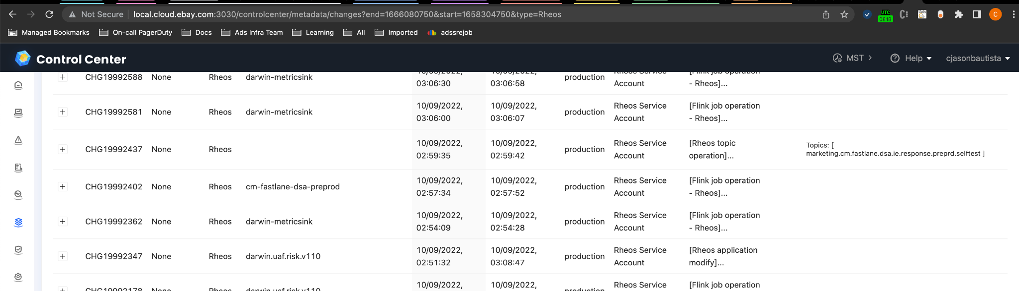

# Oct 5, 2022

Core Metrics

* Add filter to API such such ads program

Difan

* Check with curtis on how to approach testing when writing is only available to prod

How to avoid multiple ECD pipeline triggers for multiple PRs in 1 day

Learn Draft PR

* How to create a Draft PR
* How to do squash merge in PRs

Is there a window for auto-trigger for the pipeline?

* Manually merging two PRs?

Rheos

[https://ebayinc.service-now.com/nav_to.do?uri=%2Fchange_request_list.do%3Fsysparm_query%[…]rheos_streaming%26sysparm_first_row%3D1%26sysparm_view%3D](https://ebayinc.service-now.com/nav_to.do?uri=%2Fchange_request_list.do%3Fsysparm_query%3Dx_ebay_core_config_typeINdata_platforms_rheos_streaming%26sysparm_first_row%3D1%26sysparm_view%3D)

# Sep 23, 2022

**Spreadsheet API to input data**

From Freecia:

Freecia Wang

9:14 AM

Can you please share the API for adding product releases to changes page, like we have for searchsvc <https://ebay-eng.slack.com/archives/G01RH2Y6L5Q/p1663756195682189>. Pavel and Ping would like me to add the non-search launches I can manually pull from the WBR pmo presentation since there is no UI to input them

**Change Metadata Query with EP info. - Not working in Prod.**

Prod

<https://adsmetadatasvc.vip.ebay.com/adsinfra/v1/epinfo/experiments/102908>

​​<https://adsmetadatasvc.vip.ebay.com/adsinfra/v1/changeinfo/query?infer=true&start=1663352259000&end=1663394685000&type=EP>

QA

<https://adsmetadatasvc.vip.qa.ebay.com/adsinfra/v1/epinfo/experiments/102908>

<https://adsmetadatasvc.vip.qa.ebay.com/adsinfra/v1/changeinfo/query?infer=true&start=1663352259000&end=1663394685000&type=EP>

# Sep 21, 2022

**Logging in Prod**

Sl4j console log

Check instance

Validate internals

Check Log Files and CAL

<https://github.corp.ebay.com/adsinfra/adsinfra-common/blob/master/adsinfra-common-api/src/main/java/com/ebay/adsinfra/common/api/CalLogger.java>

**How to enable proxy in terminal**

Script will be provided by Honghao

Curl -v [www.latest.ebay.com](http://www.latest.ebay.com)

Source 2fa

~/Users/cjasonbautista/bin

# Sep 16, 2022

**Discussion:**

NuKV Cache to help with slow APIs

Why not just access ES?

* ES has current or last week data. It will be large. Too many records. Not in memory. It will be on disk.
* NuKV will have just the current. Read in in-memory.

Job retry limit configuration - <https://github.corp.ebay.com/adsinfra/adsinfrajob/pull/171/commits/1108d83b912ec9820d0463cff20e66d7a4841750>

Clark

Tracking

* Rheos change
* Change Type **Rheos**
* <https://jirap.corp.ebay.com/browse/RHS-11207>
* Need to follow up on Monday

# Sep 14, 2022

Placement id

* ads_infra_placement_info index

Category api

* Leaf category
  + Transaction table but maybe too much.
  + Maybe parent category
  + Published every month
* For each leaf category, whats the parent category but aggregate
* Yichao has this category request
* Need data structure design and API design

Clark

Migrate API

* Done: completed migration of data from June 1, 2021 to July 31, 2022.

Tracking

* Rheos change
* Change Type **Rheos**
* <https://jirap.corp.ebay.com/browse/RHS-11207>

Changes Metadata

* 1st column - which column
* 2nd column - change type
* 3rd Instead of Id - it will be related **tickets**

Difan

* ~~PR tested on pre-prod for adding lead, app-level oncall extension, and sample machine vi url to csv download. Waiting until all other PRs tested to deploy to production~~
* ~~Continue to improve poolList API~~

Timur

* ~~had meetings~~
  + ~~PLA data is not reliable.~~
    - ~~Need a daily digest to show latest business data~~
    - ~~For 3 days we don’t have offline data~~
    - ~~Within 3 days we show version 0~~
    - ~~After 3 days we show latest DSS data~~
  + ~~Need for unit test/tests improvement. Not just test on pre-prod~~

# Sep 9, 2022

Clark

Migrate API

* Done: completed migration of data from June 1, 2021 to July 31, 2022.

Tracking

* Rheos change
* Change Type **Rheos**
* <https://jirap.corp.ebay.com/browse/RHS-11207>

Changes Metadata

* 1st column - which column
* 2nd column - change type
* 3rd Instead of Id - it will be related **tickets**

Difan

* ~~PR tested on pre-prod for adding lead, app-level oncall extension, and sample machine vi url to csv download. Waiting until all other PRs tested to deploy to production~~
* ~~Continue to improve poolList API~~

Timur

* had meetings
  + PLA data is not reliable.
    - Need a daily digest to show latest business data
    - For 3 days we don’t have offline data
    - Within 3 days we show version 0
    - After 3 days we show latest DSS data
  + Need for unit test/tests improvement. Not just test on pre-prod

# Sep 7, 2022

Difan

* ~~Changed CMS query for retrieving pool lead information~~
* ~~Finished design doc for poolList API~~
* ~~Changed pool list content from alias to resourceId~~
* PR merged for adding lead, app-level oncall extension, and sample machine vi url to csv download
* Implement poolList API

Clark

Migrate API

* Error in prod
* ​​<https://pages.github.corp.ebay.com/geapen/rlogid/>
* t6baujfqgcbqgtuf%3C%3Dosufgvkbwdbfwduq%60%284dsi%3F*w%60ut351%3E-18318be9bbb-0x2328

Rheos change

<https://jirap.corp.ebay.com/browse/RHS-11207>

DON’T use ​​type=data_platforms_rheos_messaging,

USE

type="Rheos Streaming"

subtype=streaming_service_operation

* Timur:  
  CORS PR <https://github.corp.ebay.com/adsinfra/adsmetadatasvc/pull/65>
* OffEbay daily digest: updated placements and ES index (now it’s the same that’s used in CC)
  + maybe need placement info API to have a single source of truth

# Sep 2, 2022

Meeting notes:

Add ebay digest data as data source in Control Center

Raw data come from sellerhub clickhouse

Migrate backend data

Features for Control Center

* Daily digest numbers
* Monitor daily digest email sent out

Index being used for ebay placement in Control Center Core Metrics

* Index being used is not aligned.

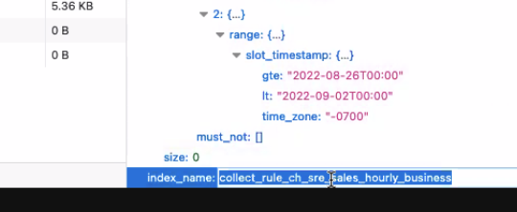

CCOE placement data source?

* Yueting has an external spreadsheet
* [External PL placement ids](https://docs.google.com/spreadsheets/d/1QR1oFUNAa7rh2e-xcpRfZ4dOGCphDto8nFvlSiG-An4/edit#gid=1549526747)
* In the future, we want this to be updated in Control Center and deprecate the use of spreadsheet.

Email digest sample

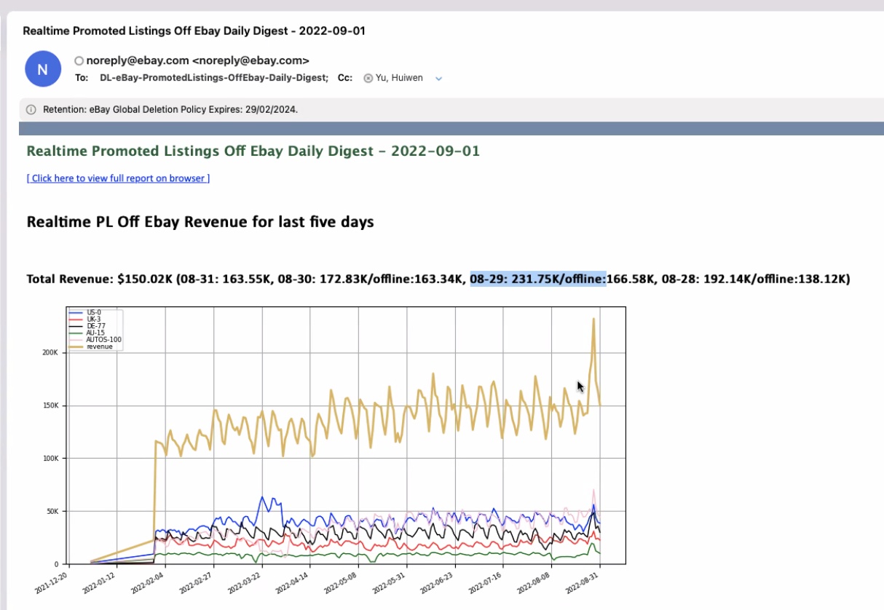

Digest problem fix:

* I want off ebay placement, hit API instead of ES query
* Migrate from shepherd backend API to adsmetadatasvc API

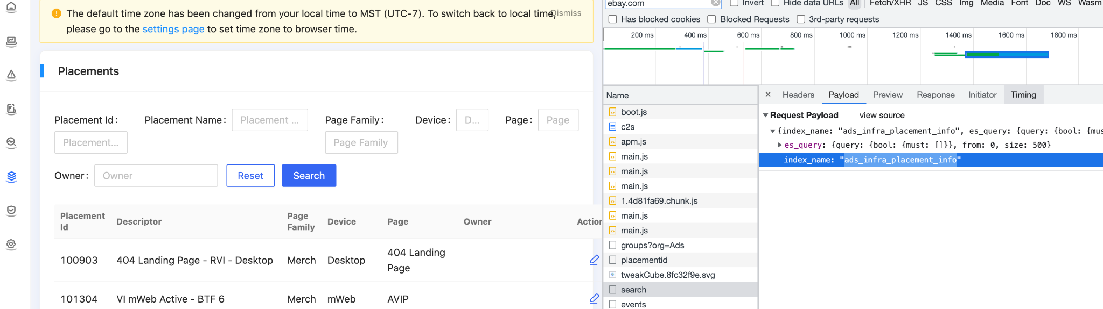

From Slack:

design doc for CMS API. Please let me know if you have any questions. <https://wiki.vip.corp.ebay.com/display/AdsInfra/CMS+API+Design>

A/B Tests & Releases - Merch <https://docs.google.com/spreadsheets/d/1szdOziD21peQOcLckLskmbloMGFWbWnSh8BWMMukz6o/edit#gid=629397258> [@freewang](https://ebay.enterprise.slack.com/team/W3Z9TCPJS)

this may be our first cases to enter in Control Center - Changes Calendar View as well

# Aug 31, 2022

**Updates for Honghao**

Clark:

[EP API Design doc](https://docs.google.com/document/d/1S_RDtpgC71RgkT2CBKXxNHUYTzBnJv3VPMLxYWXvzvA/edit#heading=h.muhiym3rtje4) update in progress

New release process for adsinfra-common <https://github.corp.ebay.com/adsinfra/adsinfra-common#how-to-release>

Difan:

Doc for architecture on pool data nukv cache and api - [Difan Yang](mailto:difyang@ebay.com)

**Action items:**

Timur:

Shepherd-ui allow origin for other API servers aside from shepherd (backend)

Clark:

additional fields to changeV2

* MFE_CONFIG
* DSS

Difan

adsinfra-common: CR (change request) creation on new releases

* Check adscanarytest5 that uses ECDx auto build pipeline

# Aug 24, 2022

DONE and fixed

Discussion:

read timeout without modifying the default ginger client setting?

Clark

* Migrate v1 index to v2
* ~~Ep info index~~
* Mfe info index
* ~~Add Change Launch type in v1 - spreadsheet job added to pre-production~~

Difan

* ~~Test cms cache layer for solving email read timeout problem~~
* Hand cms design and implementation improvement to Xinwei

Timur

* ~~Fixed some bugs in Adsintermedsvc~~
* ~~Onboard CMPaaS to Adsintermedsvc~~
* Integration tests for Adsintermedsvc in progress

# 

# Aug 17, 2022

Still working on EP info

Discussion

​​read timeout without modifying the default ginger client setting?

Rate limit? ​​<https://ebay-eng.slack.com/archives/C03AS44ETC3/p1660319086078819>

Clark

* Migrate v1 index to v2
* Ep info index
* Mfe info index
* ~~Add Change Launch type in v1 - spreadsheet job added to pre-production~~

Difan

* ~~Expand CMS API to fetch all pool metadata~~
* Fix CMS API code structure problem: change the response entity from set to object by adding new api paths
* Connect CMS API to NuKV cache and implement force refresh

Timur

* ~~Fixed some bugs in Adsintermedsvc~~
* ~~Onboard CMPaaS to Adsintermedsvc~~
* Integration tests for Adsintermedsvc in progress

# Aug 12, 2022

Clark

* ~~JIRA view - changes / pool~~
* Migrate v1 index to v2
* Ep info index
* Mfe info index

Timur

* Explore Google Sheets API for cell color
* Working on UI

Difan

* ~~Connected adssrejob to adsmetadata CMS API~~

# Aug 10, 2022

Clark

* ~~Query API~~
* JIRA view - changes / pool
* ~~Raptor upgrade - onboarded~~
* Migrate v1 index to v2
* Ep info index
* Mfe info index

Timur

* Explore Google Sheets API for cell color
* Working on UI

Difan

* ~~Connected adssrejob to adsmetadata CMS API~~
  + ~~Testing locally for adsmetadatasvc (and similar) would have infinite loop when Autowired used. Let’s instantiate adsmetadatasvc in adsinfrajob with self-defined web target~~

Montage -> App Layer -> View CMS query

Or try inspect

​​<https://montageapi.vip.ebay.com/components/entity/ApplicationService/dataquality-deployments-prod-app:ads-monitoring-prod-tessprod>

With CMS query

<https://montageapi.vip.ebay.com/components/dependency/ApplicationServiceDetail/dataquality-deployments-prod-app:ads-monitoring-prod-tessprod>

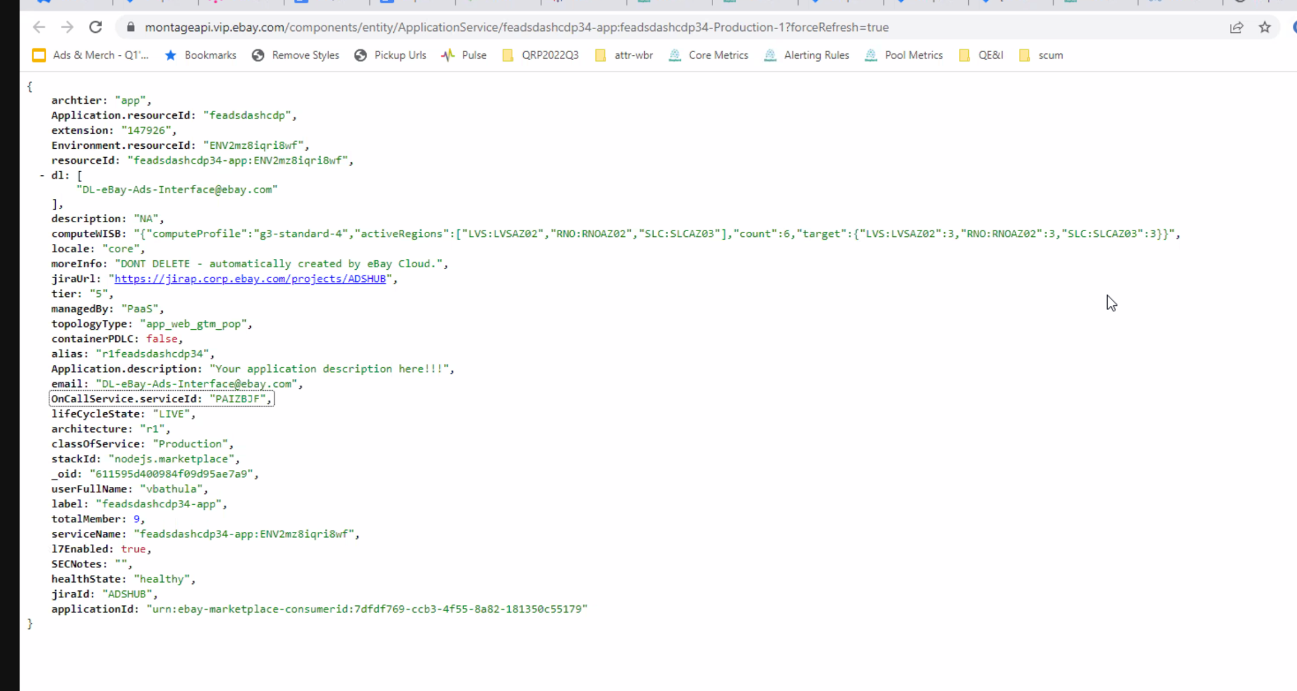

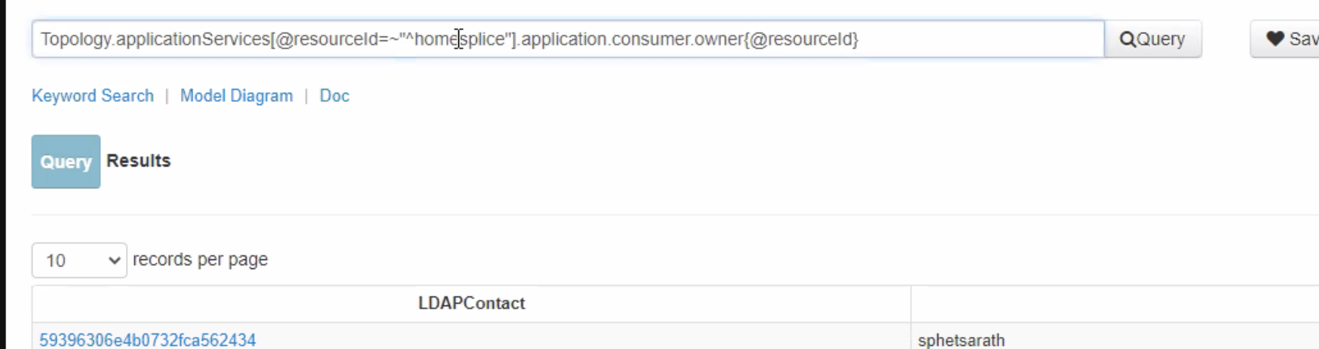

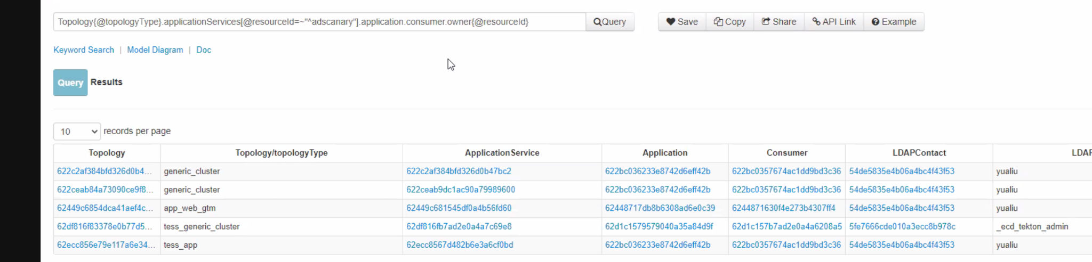

# Aug 5, 2022

Timur

* Timeline / Scope for tickets

Explore Google Sheets API for cell color

Cell values/metadata - ​​<https://developers.google.com/sheets/api/reference/rest/v4/spreadsheets/cells>

How about merged cells? I.e. June 6-7

If we can have Control Center Calendar, CCOE team is doing

How about adding the excel calendar in the control center for the time being? Maybe not needed in Control center.only needed for investigation/SOP.

CMS and github interaction

Clark

To complete by end of week for query API

* ~~Url param changed from campaign_type to ads_program - PR merged~~
* JIRA view - changes / pool
* Raptor upgrade - onboarded

Difan

* Connected adssrejob to adsmetadata CMS API
  + Testing locally for adsmetadatasvc (and similar) would have infinite loop when Autowired used. Let’s instantiate adsmetadatasvc in adsinfrajob with self-defined web target

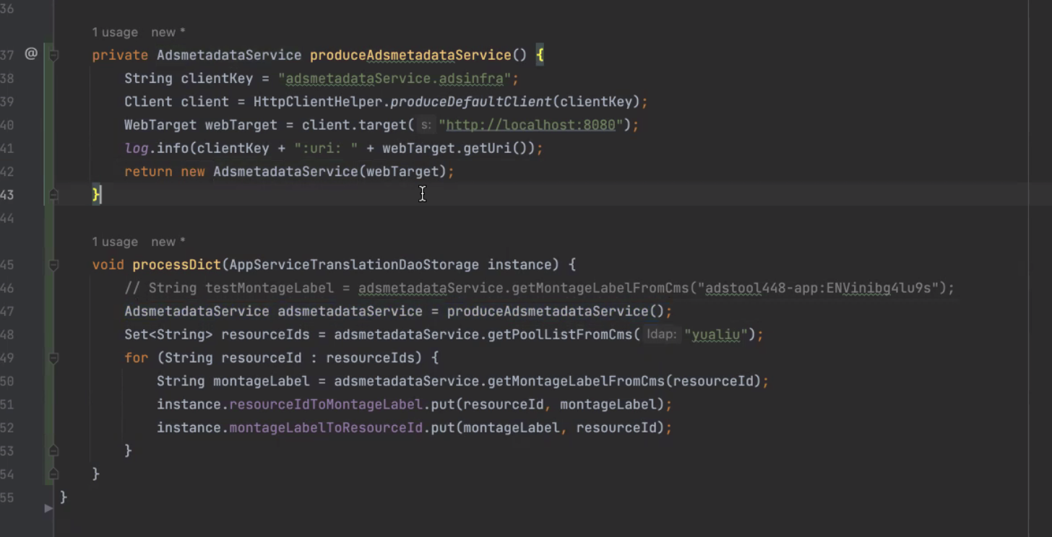

* + Maybe try Mockito, etc. ​​<https://github.corp.ebay.com/adsinfra/adsintermedsvc/blob/master/src/test/java/com/ebay/app/adsinfra/adsintermedsvc/AdsintermedsvcApplicationTest.java>
* ~~Rename getMontagaLabelFromCMS - Cannot get montageLabel from CMS, only build montageLabel~~

# Aug 3, 2022

Timur

Worked on RTBs

* Timeline / Scope for tickets

Clark

To complete by end of week for query API

* Url param changed from campaign_type to ads_program - PR merged
* JIRA view - changes / pool
* Raptor upgrade

Difan

* Connected adssrejob to adsmetadata API
* Rename getMontagaLabelFromCMS - Cannot get montageLabel from CMS, only build montageLabel